How to Remote into your Work PC
Prerequisites:
- A home computer/laptop and Operating System (Windows and MAC)
- Internet connection at home either Wired/Wireless or Hotspot for above
- Know your Staff ID and Password to login into Curtin Sites
- The Provided IP Address of your Work PC
- Your Work PC needs to be left on for you to be able to Remote In to it

To Access Your Work Computer from Home/Off Campus
- Start your Computer and connect to your wired or wireless internet at home. Open a webpage to check that you have internet access.
- Go to the Curtin Website and download the VPN Software from https://itselfservice.curtin.edu.au/CherwellPortal/SSP#1
- You will need to know to User Name {Staff\Staff Number and your Curtin Password to get in)
- Do a search for “working from home” and click Article 95: Access Your ‘On Campus’ Computer From Off Campus
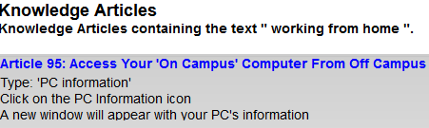
- and scroll down to, and click on the Connect to the VPN

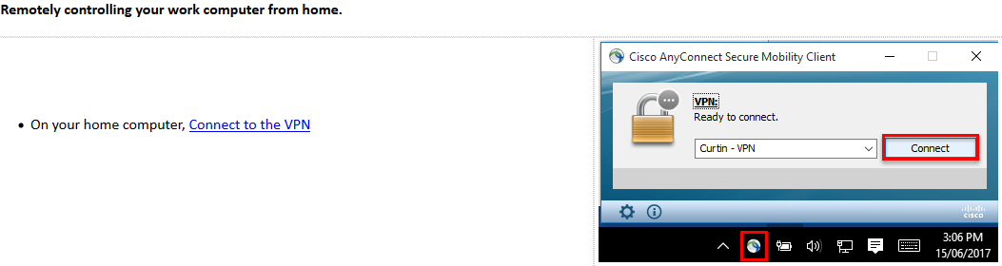
You will need to download the relevant install file for your Operating System – win or macs, if running the Catalina version of OSX pick the higher version number
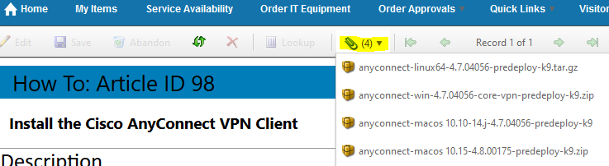

- Make sure you know where you downloaded the zip file to and install the file from its location.
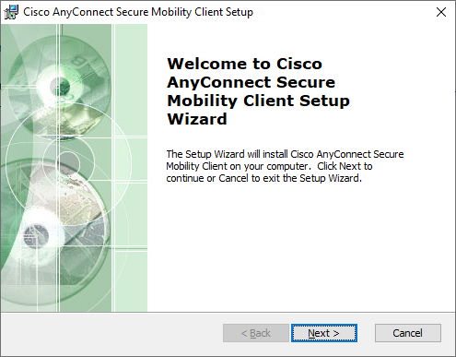
Accept the License Agreement and Next
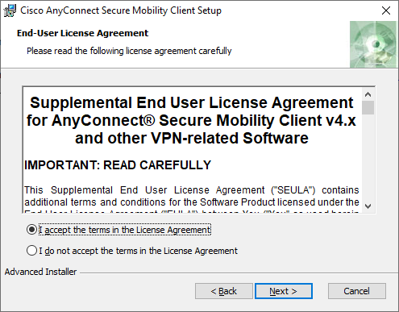
Install and Finish
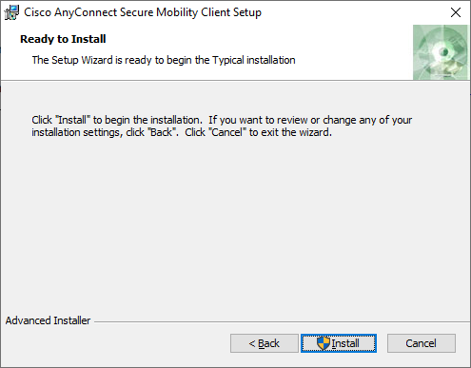
- Next you will need to open from its Installed location
- Then enter sslvpn.curtin.edu install the below opened window
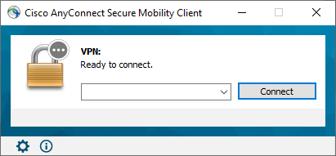
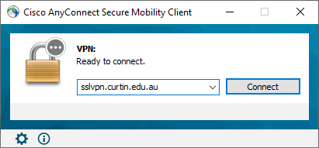
And click connect
- For this you need to know your Curtin staff Number again, which is your Username and your Curtin password. If you do not know your password, call 9000 and say you need a password for your Curtin account.
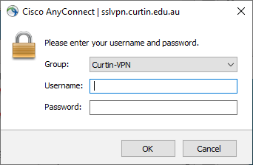
For Example
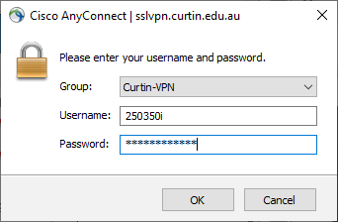
And accept the disclaimer
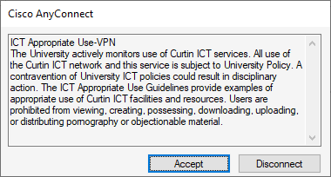
Once you are logged in, a little padlock icon will show on the AnyConnect icon in your task bar to the bottom right
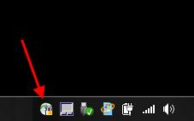
- You are now connected to Curtin’s VPN Network, this now enables you to connect to the Guild Network.
- Next you need to create a remote desktop connection session to your Guild Computer, which must be switched on or you cannot remote into it
- Go to Start or Search in Start and type mstsc, this brings up the Remote Desktop Connection or Right Click the Desktop, Select New > Shortcut and Type mstsc in the box and enter, this creates the shortcut on your Desktop and double click to Open
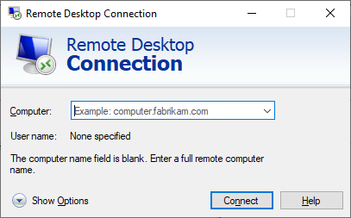
- Now Type in your provided IP Address 134.7.107.XXX (which was provided on the spreadsheet) and click Connect
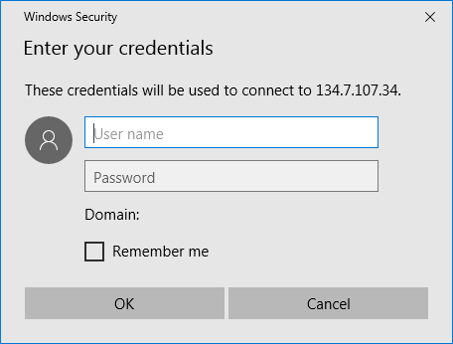
It will initiate a connection to your Guild Computer and now you need to enter your Guild Credentials
User name: - cusg\username
Password: - Your guild password
- This will Open a Remote Connection to your Guild Computer giving you Full access to your computer, essentially the same as working at your Computer at Work.

When you are finished and wish to close your session
- Click the x at the top right of the blue bar at the top of your screen to close the session
- Click the AnyConnect icon in your taskbar and this pops open the Cisco AnyConnect client and just Disconnect
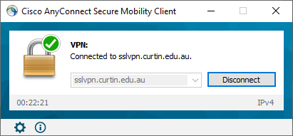

To re-establish connection after VPN installation and remote set up.
- You should now have everything set up to connect to your computer when required.
- Just click the CISCO AnyConnect icon in your taskbar area and Connect
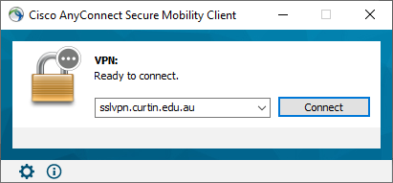
- And use the previous steps to create the Remote Desktop Session, or the Shortcut on your Desktop

